TASK 2
PEMROGRAMAN BERBASIS FRAMEWORK


By:
NAUFAL NAFIDIIN
NIM: 1941720091

PROGRAM STUDI D-IV TEKNIK INFORMATIKA
JURUSAN TEKNOLOGI INFORMASI
POLITEKNIK NEGERI MALANG
2022
- NodeJS Installation
STEP | RESULT
NodeJS download
NodeJS and NPM installation | 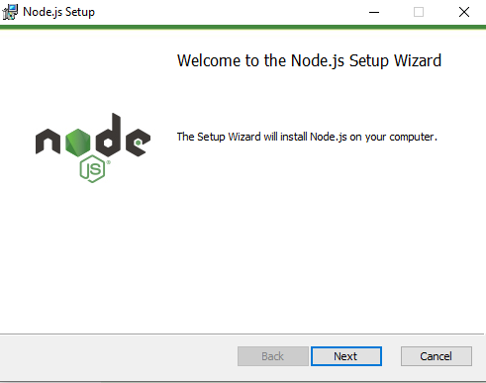  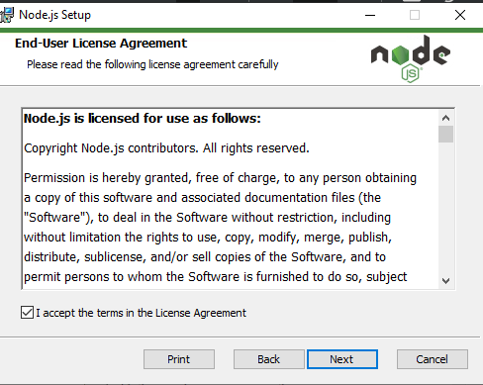  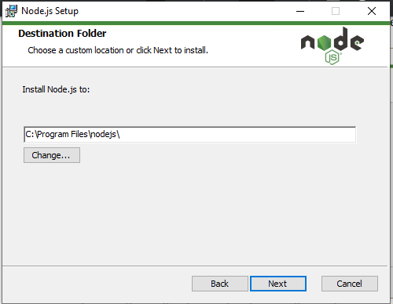  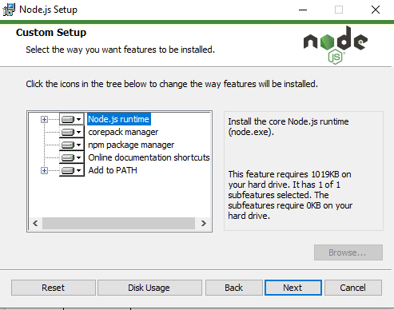  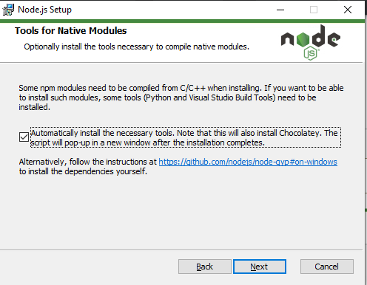  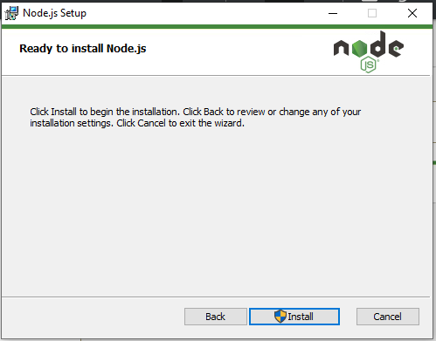  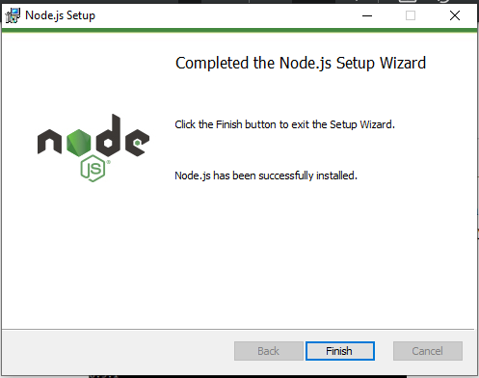
Installation Verification | 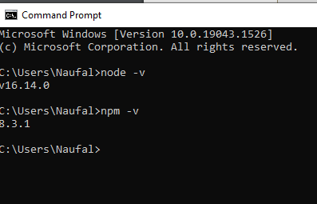

- Adding React to the website
Make a folder learn-react/week-2/web-react | 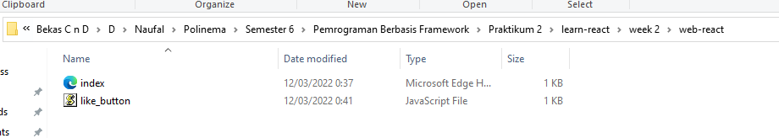
Index.html | 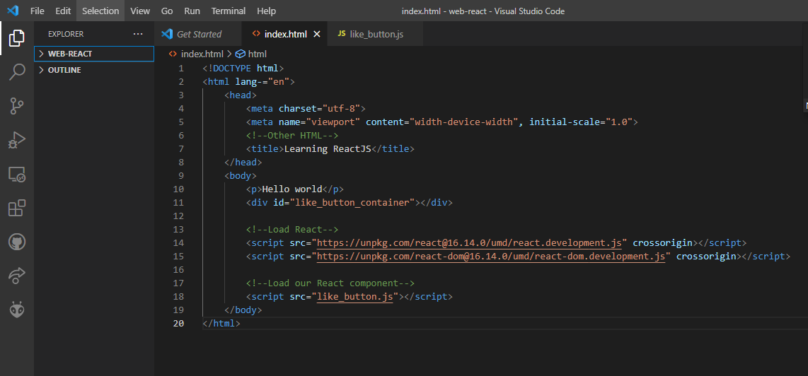
After that, create a js file with the name like_button.js | 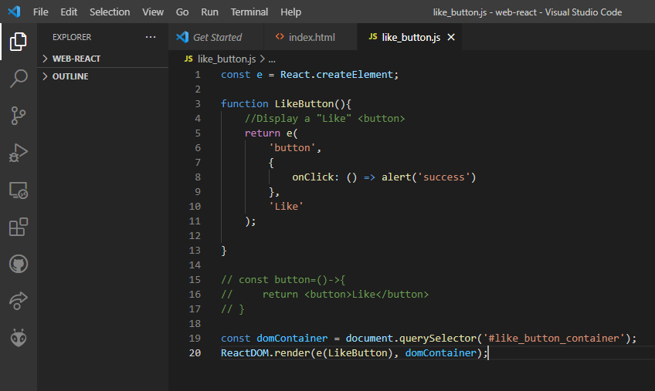
Open the index.html file in your browser | 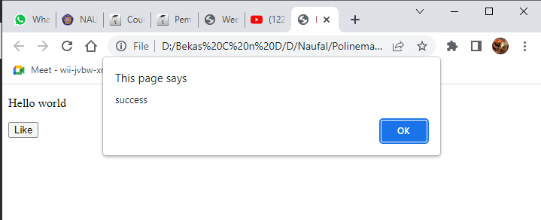

- React App Installation
Specify the location to install react, for example on windows C:\react (create the folder if it doesn't already exist, by using CMD or DOS | 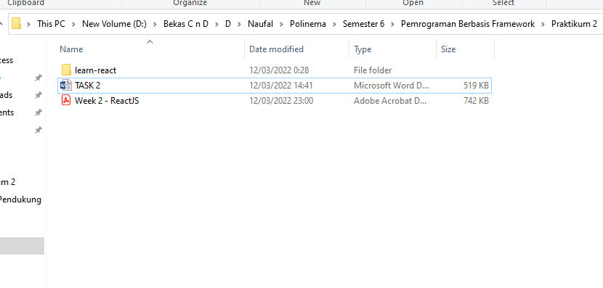
npm install -g create-react-app | 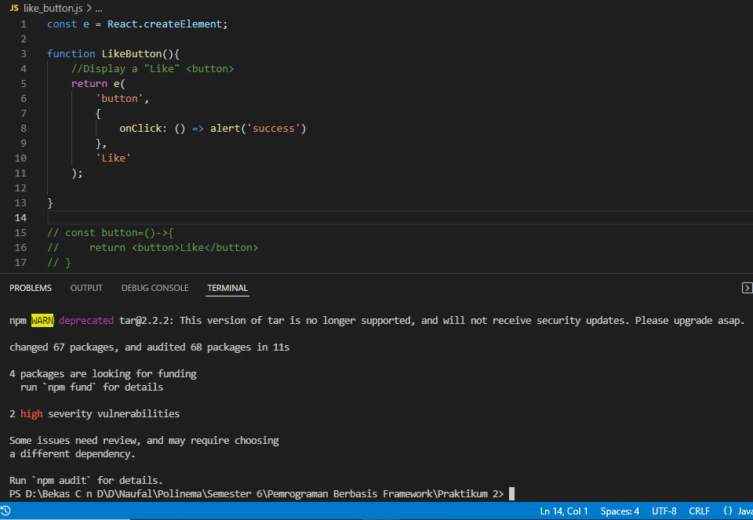
To check whether the installation was successful or not, type the following command  create-react-app --version | 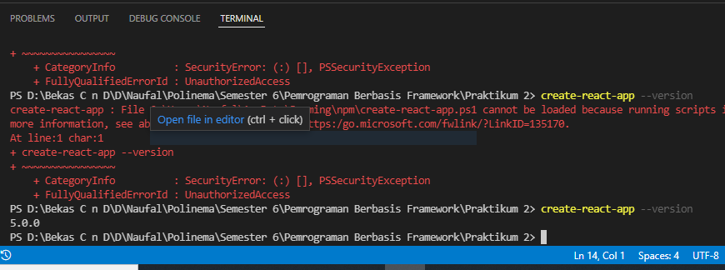
Npm install | 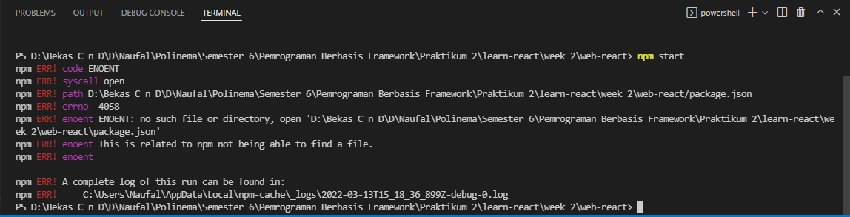
create-react-app web-reactku | 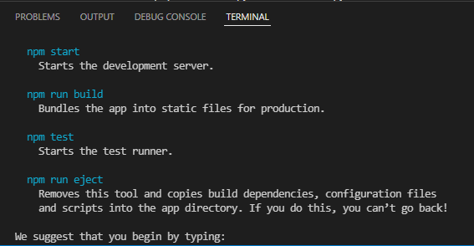
cd web-reactku  npm start | 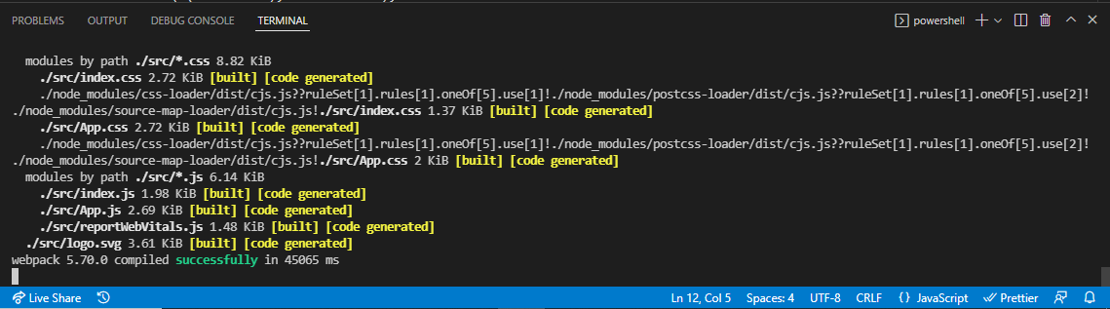
If the project has been created, there will be a new folder called learn-react on the folder where the command was executed. Now, try to open the folder with VS Code. Click the File menu -> Open Folder, then find the folder. | 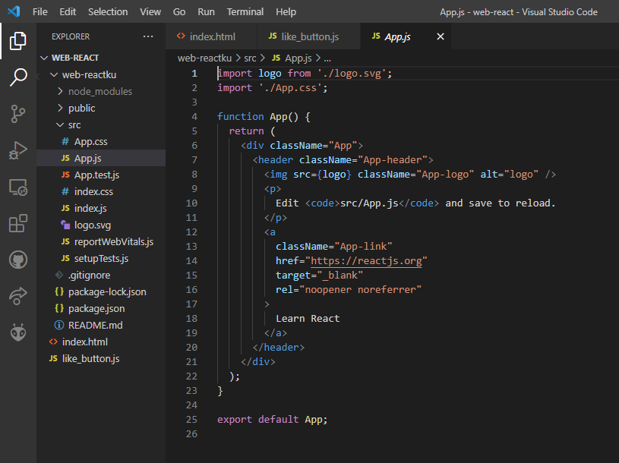
Npm scripts start | 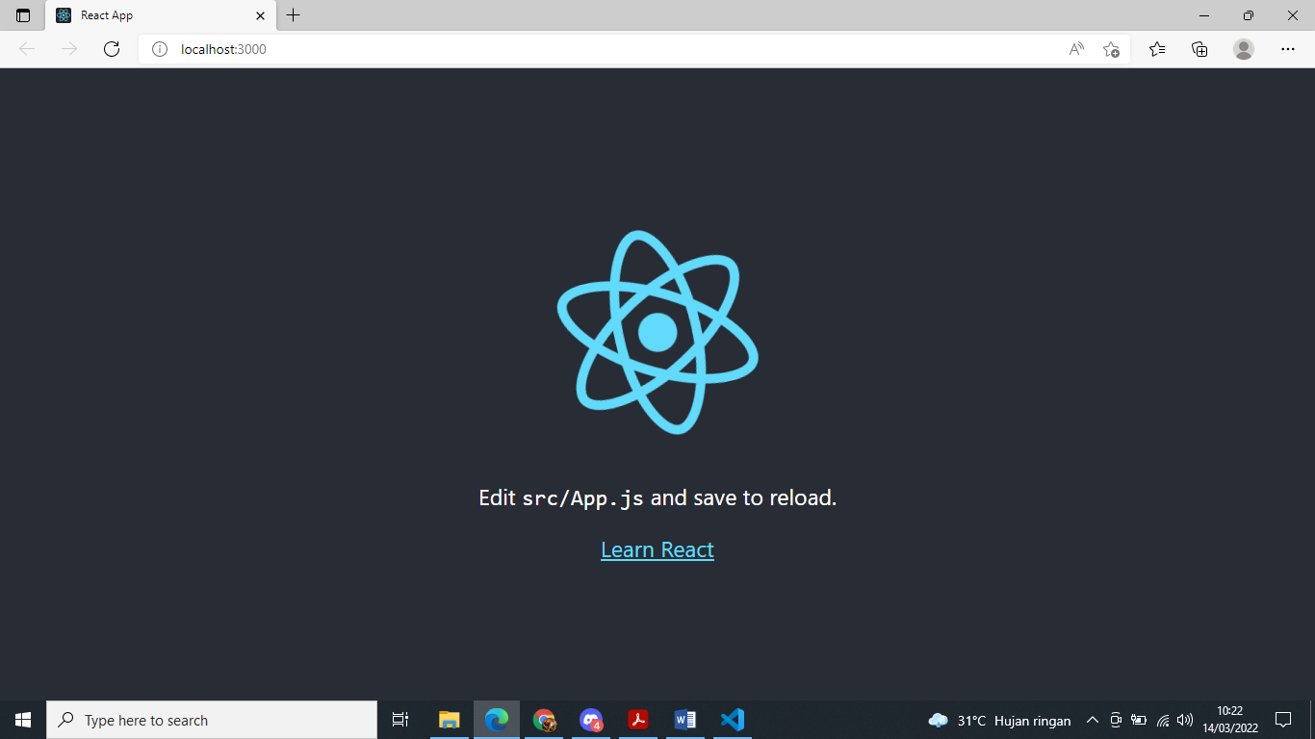

- React project structure
Index.js | 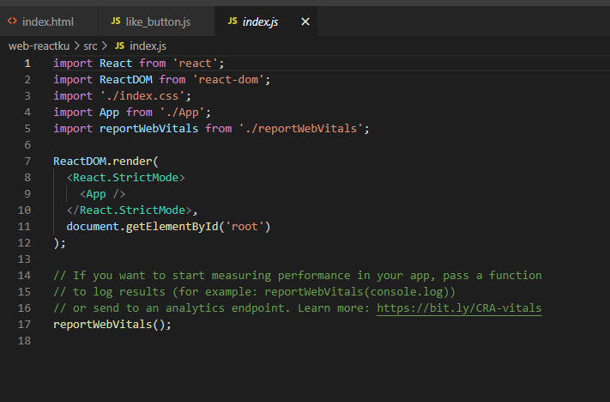
Index.html | 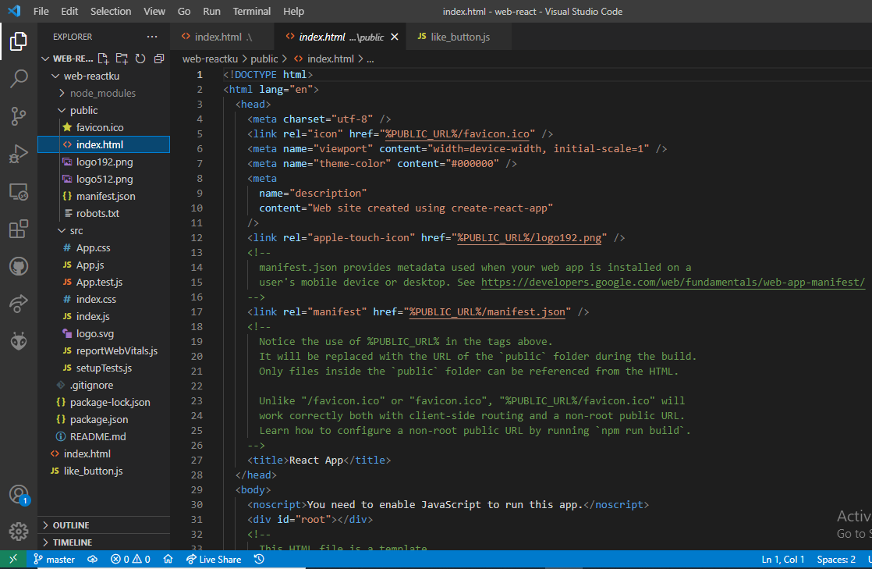
App.js | 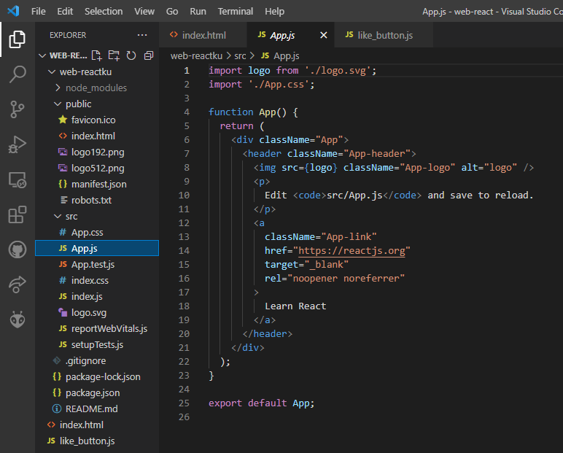
Index.js | 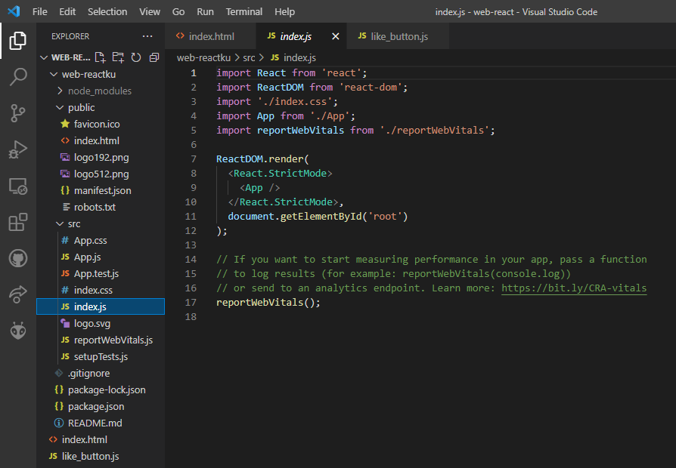

- Creating Hello Components using Arrow function
Add hello function index.js | 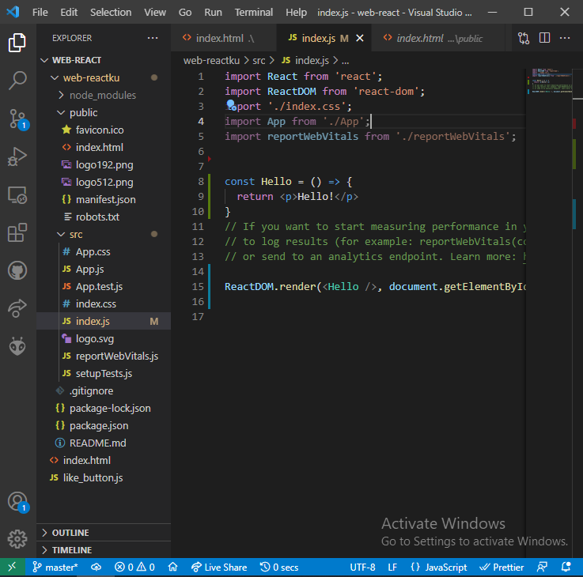
Result | 